Readonly Grid marital Status

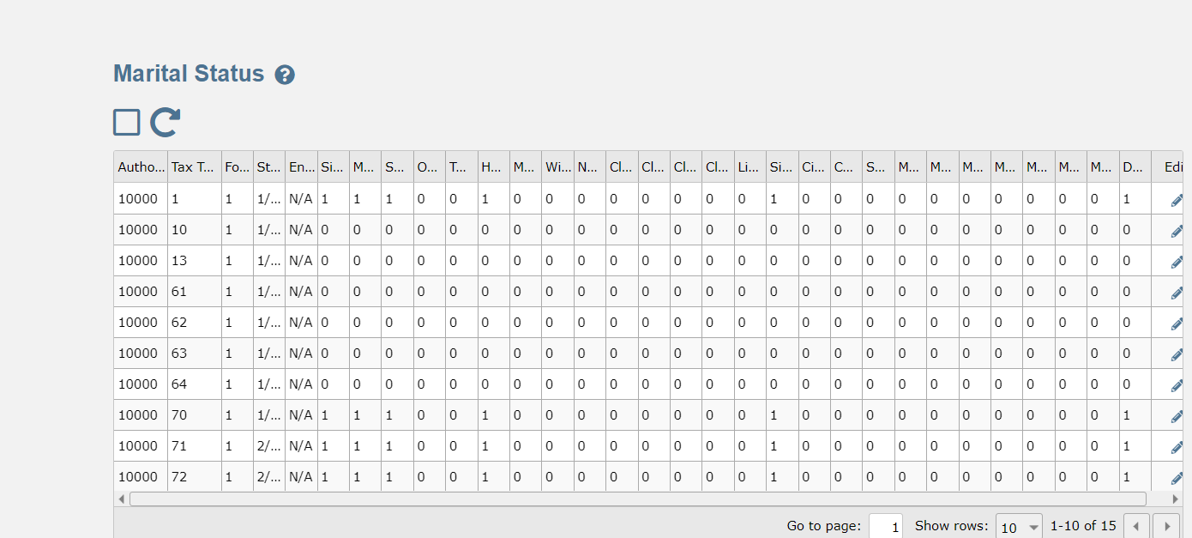

Address Overrides Grid

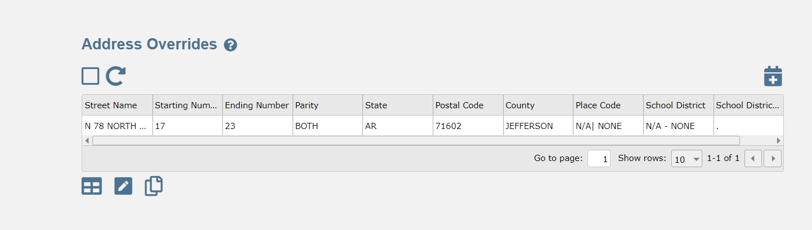

Address Override Form

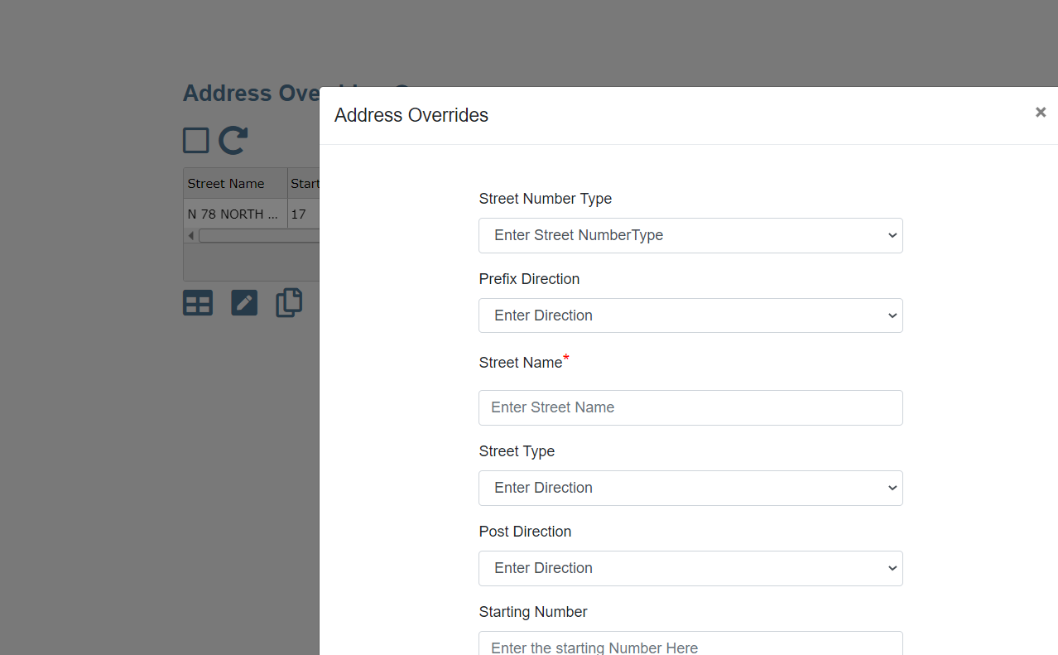

Disposable Override (Parent) Grid

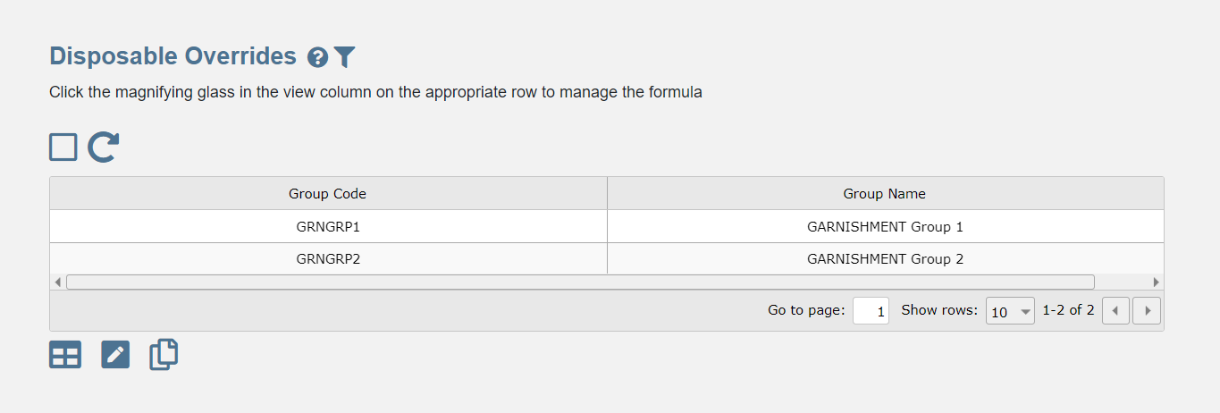

Disposable Override (Child) Grid

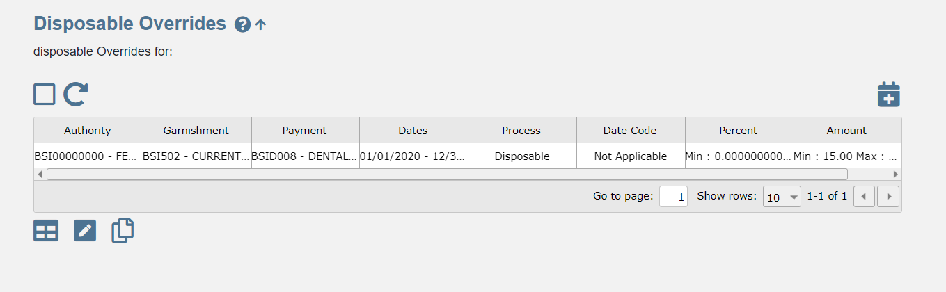

Disposable Override Form (ChIld)

